A

|  |  |  |  |  |  |  |  |  |
| --- | --- | --- | --- | --- | --- | --- | --- | --- |
|  | | | | | | | | |
|  | | DIY PROJECT REPORT | | | | |  | |
|  |  | | | | | | |  |
|  | | | |  |  | | | |
|  | | | | FINGERPRINT SAFE <https://youtu.be/kYDMhpqMymo> |  | | | |
|  | | | | SHUBENDU PANDEY ASHWANI KUMAR KAMAL KARTIK PONTULA SAILADA VISHNU VARDHAN SECTION 12  GROUP 1  TEAM 6 |  | | | |
|  | | |  | | |  | | |



# PROJECT PROPOSAL AND SIGNIFICANCE

The project is a safe-keeping box that, instead of requiring a traditional key to open, uses fingerprint recognition. This system is significantly harder to break into, since lockpicking is rendered useless and a fingerprint is much more unique and detailed, hence harder to duplicate.

This project is a prototype of what could be a commercially distributed fingerprint safe.

#### DESCRIPTION

The setup would be a wooden box with a hinged lid, and have a fingerprint sensor, an RGB LEB bulb, a power on/off switch, and a pushbutton visible on the outside. The battery powered Arduino circuit that employs the sensor would be housed inside the box, separate from the space for the belongings to be stored.

The safe would have 3 states of operation:

1. Neutral - The sensor keeps waiting to receive fingerprints. If a valid print is given, the lock opens up for 3 seconds. Correct or incorrect print is indicated by the LED turning green or red respectively.
2. Enrollment – Triggered when pushbutton held between 5-10 secs. The circuit asks for a registered print (for verification). If verified correctly, it then takes two samples of the new finger to be enrolled. The AS608 sensor module used can enroll upto 127 fingerprints.
3. Deletion – If required to wipe all prints from the sensor memory, pushbutton is to be held for atleast 10 secs. A valid print is asked for verification, and after correct print entered, it proceeds to wipe all registered prints. However, the circuit isn’t designed to function with no prints registered. Hence it immediately asks for 2 samples of a finger to be enrolled.

# OUR APPROACH

The first and foremost goal was to get a concrete picture of the physical construction of the box, which was to be made by a carpenter. Time was spent brainstorming on developing the CAD model of the safe with precise dimensions. The final STL files of the box models, and some screenshots with dimensioning can be found [here](https://drive.google.com/drive/folders/1uTyTycrIWJH5AtkpgVeQ-lq2Msi23NFL?usp=sharing).

Some images are shown below:

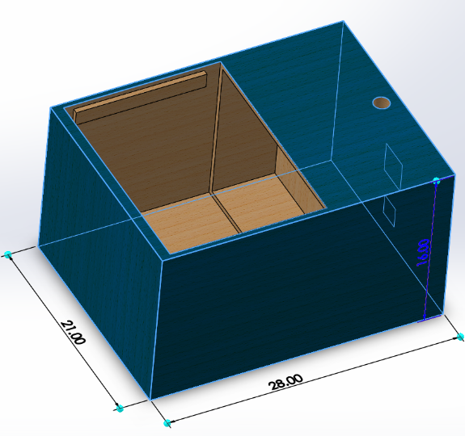 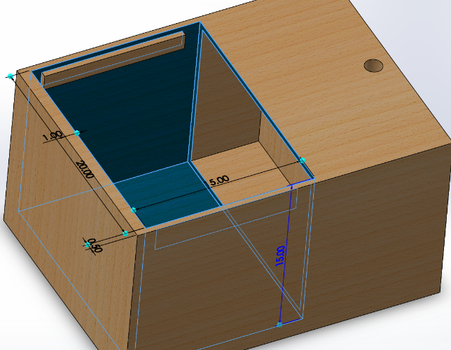

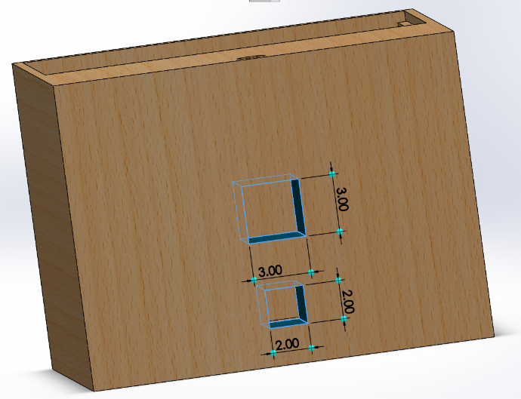 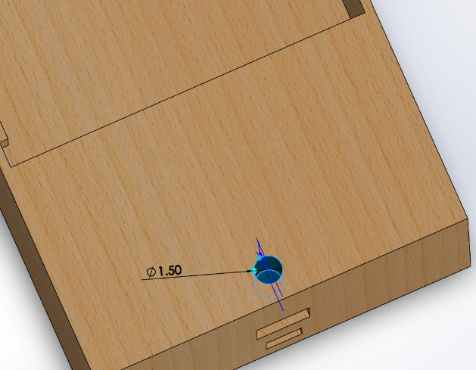

# OUR APPROACH

The components decided to be used were:

1. Arduino Uno R3
2. AS608 fingerprint sensor module
3. Wooden box, with hinges and a handle
4. Solenoid Lock
5. Relay module (for the solenoid lock)
6. RGB LED
7. Pushbutton and switch
8. 12 V DC power supply
9. Jumper cables

After this, the schematic circuit diagram was prepared:

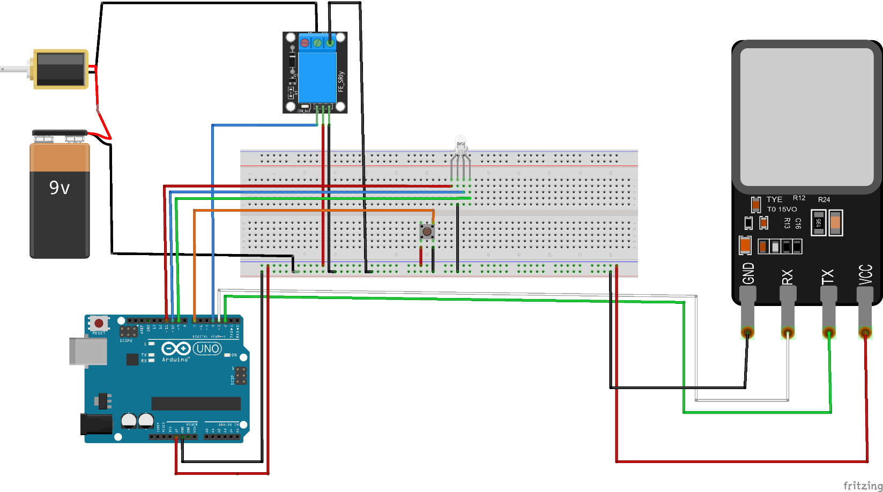

Button

Fingerprint Sensor

RGB LED

Relay

Module

Arduino

Battery

Solenoid Lock

# OUR APPROACH

The hardware before assembly:

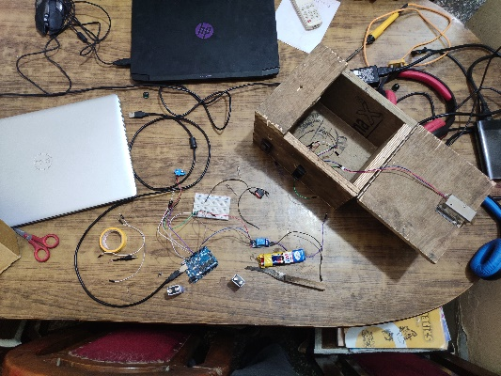

After assembly:

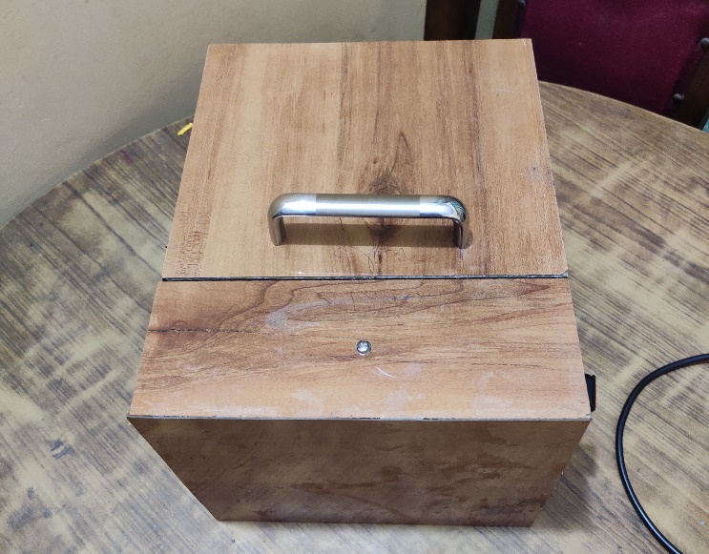 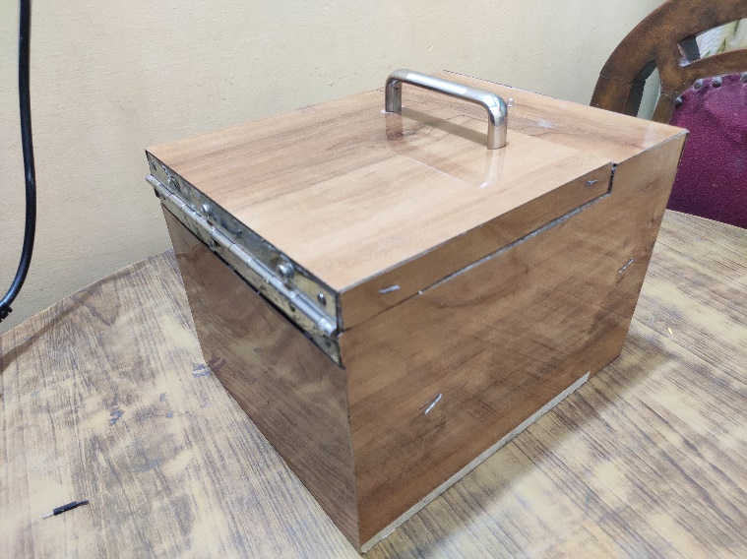

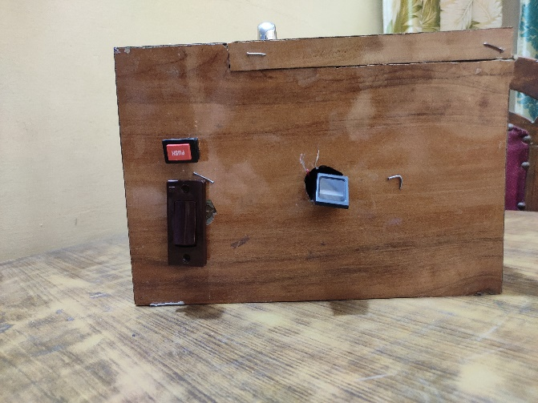 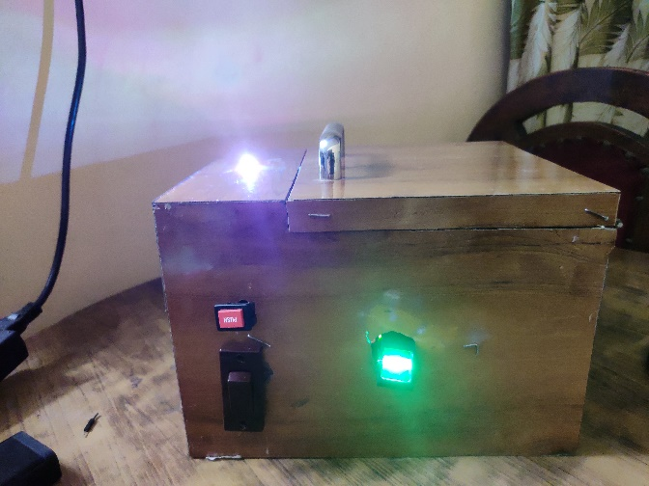

# OUR APPROACH

A sample testing code was used for the setup initially, to detect faults in hardware if any. The last week was spent on writing the final Arduino code, which can be found [here](https://github.com/KPontula/VASK/blob/main/final.ino).

Note: The statements involving Serial are used for bug testing. They are to be commented out for regular operation of the safe without a USB connection.

getFingerprintIDez() : checks the input fingerprint

getFingerprintEnroll() : enrolls new fingerprint

finger.emptyDatabase() : clears all saved fingerprints

# OVERALL WORK DISTRIBUTION

##### SHUBHENDU PANDEY

* Made the CAD models and played a major role in design work
* Used ANSYS to test the strength of the box
* Contributed to the code

##### ASHWANI KUMAR KAMAL

* Acquired all hardware necessary and assembled the project
* Designed the circuit
* Played major role in code improvement and bug testing
* Participated in box design

##### KARTIK PONTULA

* Played major role in code improvement and bug testing
* Played a role in CAD modelling and participated in box design
* Created weekly reports and edited the presentation video

##### SAILADA VISHNU VARDHAN

* Created the basic structure of the final code
* Participated in box design

# ISSUES ENCOUNTERED

* The slot for the sensor was not made on the front face of the box as expected, owing to a miscommunication with the carpenter who made the box.
* In case of a circuit failure or battery discharge, the box would be unopenable (unless brute force is used). To open the solenoid lock without using the sensor, two extra wires have been drawn out from the lock terminals to the outside of the box, so that the lock can be opened with an external DC source.
* The duration of button presses measured is occasionally quite higher than the actual duration of press. This is clearly an issue in the circuit wiring, and needs to be fixed for better timing accuracy.

# CONCLUSION

The fingerprint sensor has been successfully implemented (albeit with minor flaws) and shows the desired behavior.